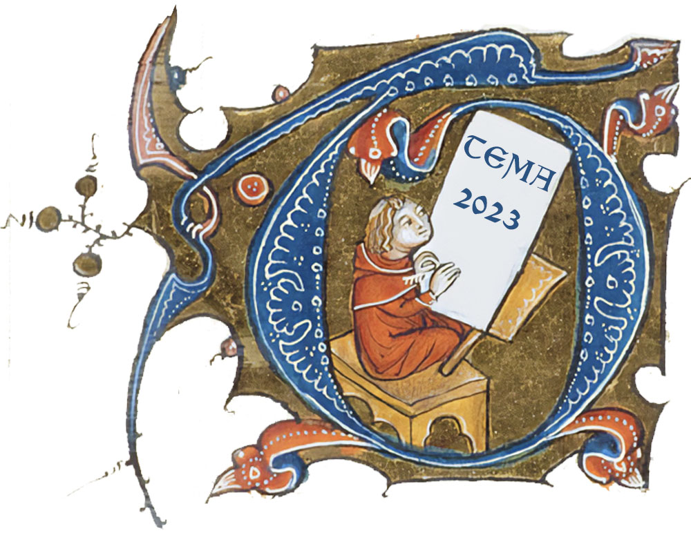
TEMA 2023 Registration
Texas Medieval Association
Medieval Studies Program
Southern Methodist University P.O. Box 750432 Dallas, Texas 75275–0432
(214) 768–2949 email: bwheeler@smu.edu
web: https://www.texasmedieval.net/ and http://www.smu.edu/medievalstudies/
Contact Information
Title
Name
Address
City
State
Zip
Country
Phone
Email
Affiliation/School
Are you presenting a paper or hosting a roundup/session at TEMA 2023?
Do you require A/V equipment? If yes, what do you require?
Do you know of any new or emerging medievalists in Texas who might welcome being invited to TEMA?
Do you require any special accommodation? If so, please specify. We are unable to provide childcare.
In case of emergency, please provide the name of an emergency contact with email and phone number.
Check whether you are staying for tapas/paella dinner. ($20 for students, $25 for faculty)

Registration Costs
Faculty Registration | $20
Student/Other Registration | $10
Dinner (student) | $20
Dinner (faculty) | $25

Registration includes:
Attendance at all ‘Round-Ups’, Regular Sessions, and Plenary
Lunch, Saturday
Coffee Service, Saturday
SMU Meadows Museum of Art visit
TEMA Annual Membership Dues
Other Attendees are welcome without charge to attend Regular Sessions, Plenary, and ‘Round-Ups’ as space allows but are only welcome to dinner if they pay full dinner charges.
Pay by check made payable to Don Kagay at 12111 Sunland St, Dallas, TX 75218 or by Zelle to
214-213-9927. Receipts will be available at the Conference Desk.
Email completed registration form to bwheeler@smu.edu or ciwhite@smu.edu

